Sky Labs is a healthcare company that predicts diseases in daily life using big data with continuous monitoring devices and AI platform.
CART-I, a ring-type medical device for continuous Atrial Fibrillation monitoring without user intervention.
CART-I on the finger collects both ECG and PPG signals and then analyzes the data to obtain information on the pulse rate and Atrial Fibrillation. ECG is more accurate than PPG but PPG has a higher probability of detecting irregularly occurring episodes. Having both techniques together can significantly increase the chance of detecting AF.
Why ring-type?
Finger is the most ideal measurement site where it provides more accurate and better signal quality
- Abundant supply of arterial blood
- Highest amplitude
- The smallest pulse peak time & reflection index for PPG
- Easier to affix sensors
- Could minimize the motion artifact
The critical need for early AF detection
- Asymptomatic AF can increase the risk of stroke
- Low probability of capturing an irregular heartbeat
- No existing medical devices that ensure convenience and continuity of AF monitoring
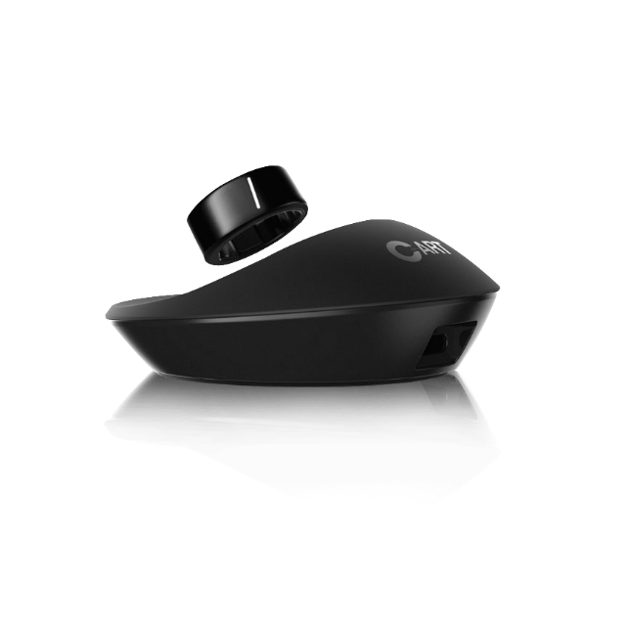
Medical-grade platform of CART-I allows outpatient monitoring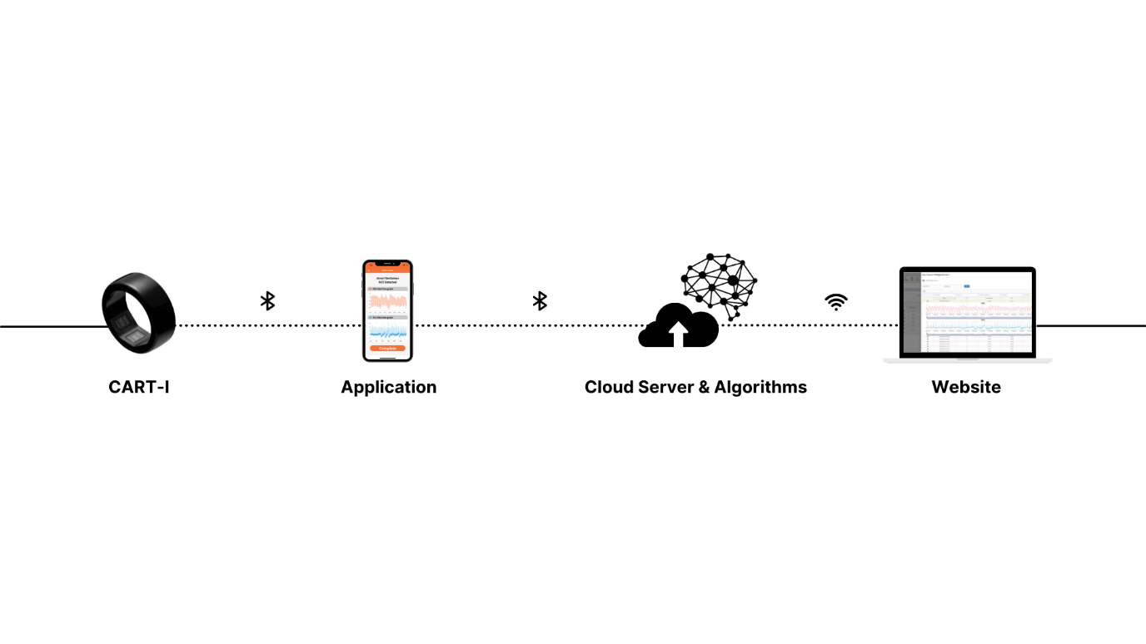
CART-I provides an advanced platform for users and physicians to easily access their data and monitor their signal patterns.
- CART-I measures both PPG and ECG signals by continuous monitoring.
- Patients can access their health data immediately through an application installed on their mobile phones. They can get notified when AF has been detected.
- With its 99.6% accurate detecting AF Deep Learning Algorithms, trustworthy data will be transferred to physicians.
- Physicians then can provide feedback and monitor patients through checking the data.
Sky Labs has been making great strides since it was founded in 2015. Sky Labs won the final of the Grants4Apps held by Bayer, a German multinational pharmaceutical company, in 2017, Sky Labs attracted investment from Bayer Headquarters. Sky Labs is the only Korean company that won the Digital Health and Technology Competition of the European Society of Cardiology for 2 consecutive years. In addition, the company was invited as a technology pioneer to the World Economic Forum 2019. Aside from these, Sky Labs won the Young Investigator Award 2019 from HRS and managed to get CE-MDD Approval and Korean MFDS Medical Device Approval in 2020. Sky Labs has officially launched in Korea in 2020, strategic investment and domestic sales rights were contracted with CKD in the same year. The following year, Sky Labs awarded for Red Dot Winner2021. CART-I was chosen as one of the wearable devices for a clinical trial to evaluate the effectiveness of alerting AF patients to take anticoagulants when needed. The study is led by Dr. Timothy Betts, professor of medicine at Oxford University, who is a cardiologist and arrhythmia specialist. In May, Sky Labs closed a contract with Titan Commerce Continental Services, the largest wearable medical device distributor in Germany, to sell CART-I in Germany, Austria, and Switzerland. The company is intending to take over the global market.

