Fact sheets for CES 2023 highlight technologies
iSportWeaR
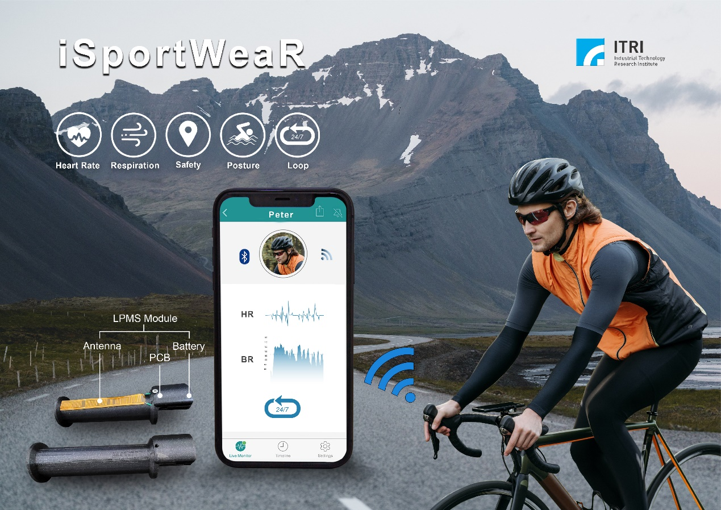
iSportWeaR is a smart personal health management solution for fitness and sporting enthusiasts. It measures heart rate, breathing rate, and activity behavior, and wirelessly sends alerts of abnormal conditions with non-contact radar sensing technology. This unique product helps athletes understand their health status and optimize exercise training easily.

Technology breakthroughs and features
- Novel Design: Unlike those only with built-in Bluetooth earphones and microphones, iSportWeaR glasses center on digital health monitoring and are specifically designed for sports and fitness. The application in bike handle grips is the first of its kind in the current bike accessory market, marking a breakthrough in health-monitoring cycling solutions.
- Non-Contact Monitoring: iSportWeaR does not require direct skin contact and works with sweat interference. Cyclists can monitor their heart and respiration rates, even with gloves.
- Robust and Flexible Applications: iSportWeaR works indoors or outdoors, rain or shine. It can be integrated into various accessories for customized training needs. ITRI has worked with a world-leading bicycle brand and an e-bike company to develop iSportWeaR applications in cycling.

Technological specifications
- Non-contact sensing module: LPMS
- Measurement Distance: 0-15 cm
- Heartbeat: 48-240 beats/min
- Respiration: 6-60 breath/min
- Dimension: 15*2 cm
- Accuracy: ≥ 95 % (stable condition)
- Communication: Bluetooth BLE
- Working temperature: 5-50 °C
- Working Humidity: 10-90% RH

Applications
- Sports glasses
- Bike handgrips
- Sports Helmets

Digital Twin for Sport Guidance with Vital Sign Sensing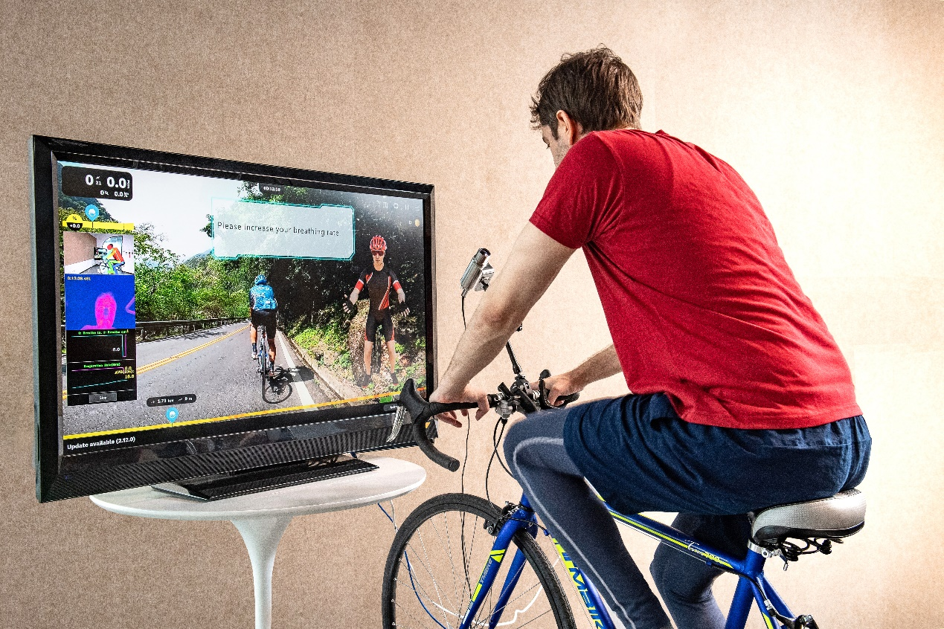
ITRI’s Digital Twin for Sport Guidance with Vital Sign Sensing was developed for indoor bike training, incorporating non-contact detection technology and big data analytics to provide advice on biomechanics and coordination. The system measures respiratory rate via thermal sensing and includes a depth camera for skeletal imaging and motion tracking.

Technology breakthroughs and features
- First of its kind in cycle training: It is the world's first innovation that incorporates non-contact thermal imaging respiration measurement technology into cycle sport breathing training. Without any monitoring wearables, users can focus more on realistic road condition simulations and enhance training effectiveness.
- Comprehensive analysis: It analyzes the user's back, shoulders, elbows, arms, hips, and knees through image-based skeletal movements.
- Professional guidance: Comparing the collected data with the statistics of national-class cyclists, this digital coach offers instructions to regulate breathing and improve riding postures. It also provides professional-level suggestions on motion strength and body coordination in real time.

Technological specifications
- Respiration rate error < 2 bpm
- Joint angle resolution < 2。

Applications
- Indoor cycling training
- Flywheel training

AI Aquarium
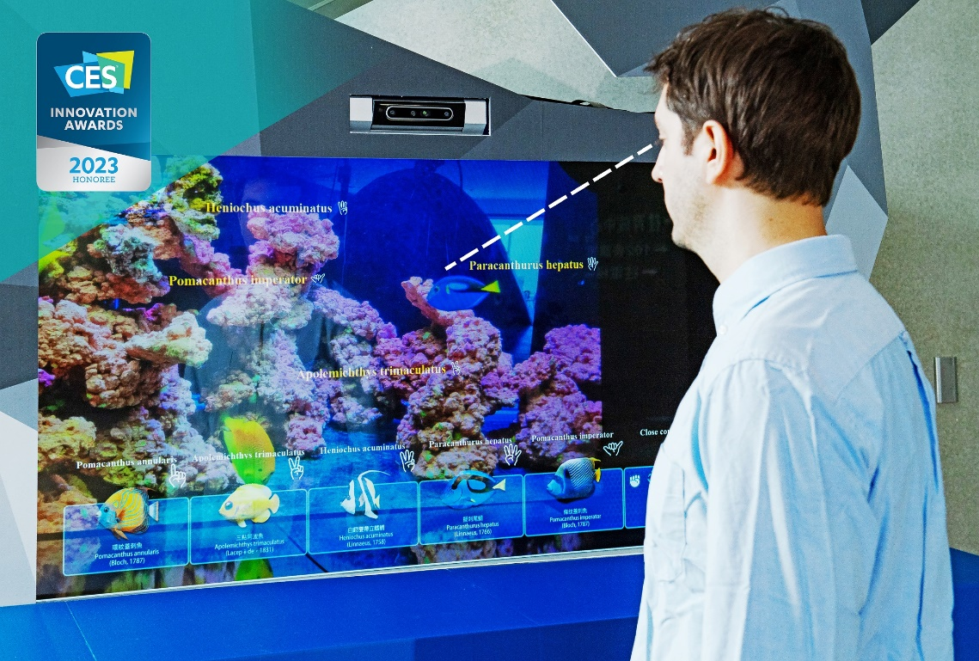

AI Aquarium is a CES 2023 Innovation Awards honoree. It is the world’s first smart aquarium that helps observers identify marine life in real time. With intuitive virtual-real fusion, the system can recognize aquatic species and show corresponding information on a transparent display according to an observer’s line of sight. AI Aquarium also performs gesture recognition with up to 98% accuracy.

Technology breakthroughs and features
- Compact apparatus: The technology can precisely detect/identify observers and marine life while displaying information instantly.
- AI classification of aquatic animals: With images captured from marine life, the database can scale up immensely via data augmentation, which significantly increases recognition accuracy.
- Contactless interaction: AI Aquarium tracks an observer’s line of sight to show corresponding information on the system display, even if the observer wears a mask. AI Aquarium also uses gesture recognition to display relevant information.

Technological specifications
- Virtual-real fusion
- AI classification
- Contact-free interaction

Applications
- Information guidance
- Smart window: sightseeing guidance
- Exhibition
- Smart edutainment
- Retail display
- Surgical simulation

Cubot ONE: Indoor/Outdoor AMR
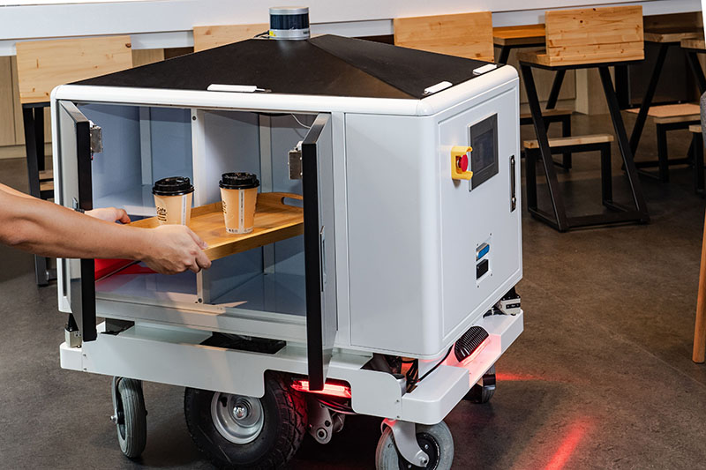
Cubot ONE: Indoor/Outdoor AMR is an autonomous mobile robot (AMR) that can avoid pedestrians and obstacles, travel on ramps, take elevators, and navigate signaled intersections, creating more possibilities for the logistics industry.

Technology breakthroughs and features
- Indoor/outdoor functionality: Unlike most AMRs that can only move on flat ground, Cubot ONE is suitable for rough or uneven surfaces. It can also operate indoors and outdoors, rain or shine.
- Integrated vehicle communications: Cubot ONE is integrated with cellular vehicle-to-everything (C-V2X) communications to safely cross intersections installed with C-V2X roadside units. 5G connectivity enables Cubot ONE to interact with elevators, making deliveries to multi-level buildings possible.
- AMR fleet management: A backend management platform can orchestrate multiple Cubot ONEs and coordinate the traffic in an area.

Technological specifications
- Physical dimension (inches)
  - Length* Width* Height: 41.3 *26.6* 42.5
- Weight (pounds): 330.4
- Mobility: Max. speed 7 km/h
- Climb grade: 15 degrees
- Load: Max. 100 kg
- Power
  - Battery: LiFePO4 24V DC
  - Capacity: 50 Ah
  - Run time (without load): approximately 4 hrs
  - Charging time: 4 hrs
  - Life cycle: 2000 recharge cycles
  - Charging method: Automatic/manual
- Protection features
  - 3D Lidar Velodyne VLP-16 *1
  - 2D Lidar SICK TIM561 *2
  - Emergency stop button *1
  - Vision camera: Intel Real-Sense camera on the front
  - Warning lights: Red LED lights
  - Speaker: 3.5 in., 20 W max
- User Interface
  - One HMI on the front

Applications
- Logistics
- Retailer
- Food delivery
- Library for autonomous book return

RobotSmith
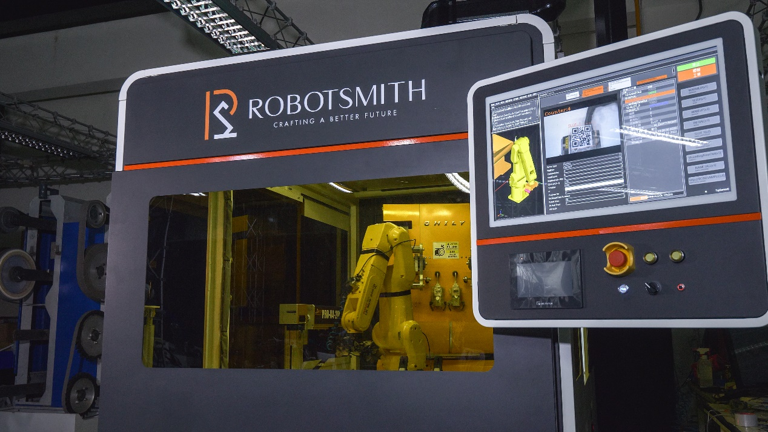

ITRI’s RobotSmith is a cyber-physical system for metal workpiece grinding and polishing. It incorporates sensing, robotics, industry best practices, and the in-house developed software EzSim to offer a total solution for surface finishing. The system performs trajectory planning and optimizes path parameters to achieve high precision and efficiency.

Technology breakthroughs and features
- High-quality surface finishing: The robot employs AI software to mimic human skills and overcome process bottlenecks. The EzSim software completes the robot’s simulation and optimizes its grinding trajectory, allowing RobotSmith to perform surface treatment as delicately as a human expert.
- Easy and rapid deployment: The robot can be easily deployed in traditional industries to implement digital transformation while preserving craftsmanship skills required for production lines.
- Digital Transformation: RobotSmith digitalizes the grinding techniques of experienced workers and removes the limitations of human labor and manual precision.

Technological specifications
- Dimension (ft): 6.5 x 6.5 x 6.5
- Workpiece weight limit (lbs): 7.5
- Workpiece size limit (in): 4 x 2 x 3

Applications
RobotSmith can be used to grind and polish metal workpieces to produce products such as plumbing fixtures, high-end knives, and artificial joints.

