Etron Technology Inc.

Additional Etron@CES 2023 multimedia content including highlight technology photos and videos are available for download
https://etrnas2.etron.com.tw/file_station/sharing/KrEaH2Sdi

Summary
Item | Contents
Logo | https://etrnas2.etron.com.tw/file_station/sharing/6tZenBBpE
Company Profile | https://etrnas2.etron.com.tw/file_station/sharing/avJcb11XF
Video | Etron@CES2023 Preview  For Download  https://etrnas2.etron.com.tw/file_station/sharing/LgjjyY1h1  For Viewing  https://www.youtube.com/watch?v=5ePguXpGbb0&t=31s
Image | 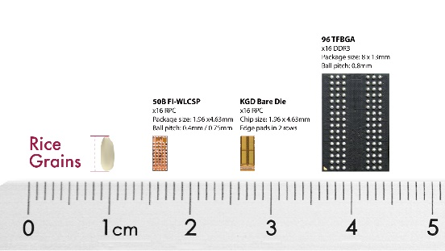  https://etrnas2.etron.com.tw/file_station/sharing/lqOgMNo6h

Item | Contents
Image | 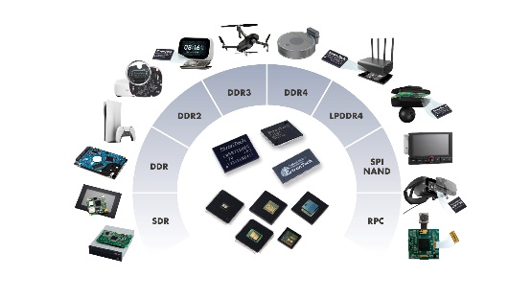 https://etrnas2.etron.com.tw/file_station/sharing/p8Mix19YP
Image | 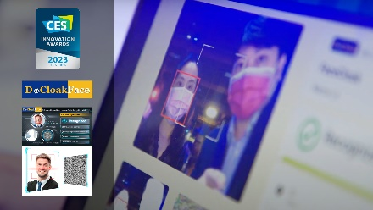  https://etrnas2.etron.com.tw/file_station/sharing/l0iB4OMZv
Image | 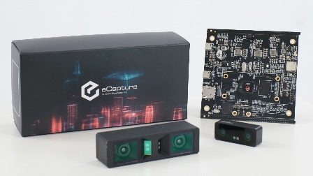  https://etrnas2.etron.com.tw/file_station/sharing/8juaflAII
Image | 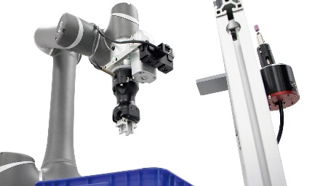  https://etrnas2.etron.com.tw/file_station/sharing/bcpzuse7T
Image | 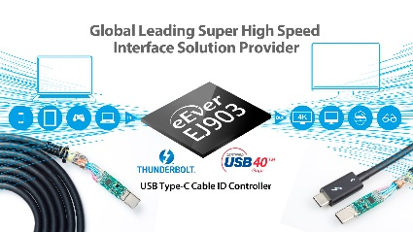  https://etrnas2.etron.com.tw/file_station/sharing/ZWhHRlkc3
Product Selection | https://etron.com/longevity-product-table/
Item | Contents
News Release | <CES2023> Leverage the design capabilities of Memory and logic ICs, Etron Technology is committed to delivering the comprehensive memory solutions with Innovation and building a more resilient supply chain with customers  https://etrnas2.etron.com.tw/file_station/sharing/fwQGMQ9oU
News Release | Etron Honored with 2022 Hsinchu Science Park R&D Achievement Award for Outstanding R&D Accomplishments  https://etrnas2.etron.com.tw/file_station/sharing/4bDQjORKE
News Release | DeCloakFace is here to protect your facial recognition privacy!!(CES2023) DeCloak has been named a CES® 2023 Innovation Awards Honoree for DeCloakFace  https://etrnas2.etron.com.tw/file_station/sharing/rYdEZPvE4
ANews Release | eEver’s USB Type-C Cable ID Controller－EJ903x that supports USB-IF’s Latest USB4® v2.0 Specification to Enable USB 80Gbps Performance of Four channels, Bi-directional Data Transmission over the USB Type-C® Cable and Connector  https://etrnas2.etron.com.tw/file_station/sharing/KsYlYOo95
News Release | Leopard Imaging and eYs3D Jointly Launch the First GMSL & GMSL2 Video and 3D Depth Cameras  https://etrnas2.etron.com.tw/file_station/sharing/krGPCo27l
News Release | eYs3D Launches One - Stop XINK Development Platform for Vision-Equipped Robots  The Platform-as-a-Service Uses SoM (System on Module)  https://etrnas2.etron.com.tw/file_station/sharing/tXjymSGH9
News Release | STMicroelectronics and eYs3D Microelectronics to showcase collaboration on high-quality 3D stereo-vision camera for machine vision and robotics at CES 2023  https://etrnas2.etron.com.tw/file_station/sharing/KcIeSAtgJ

