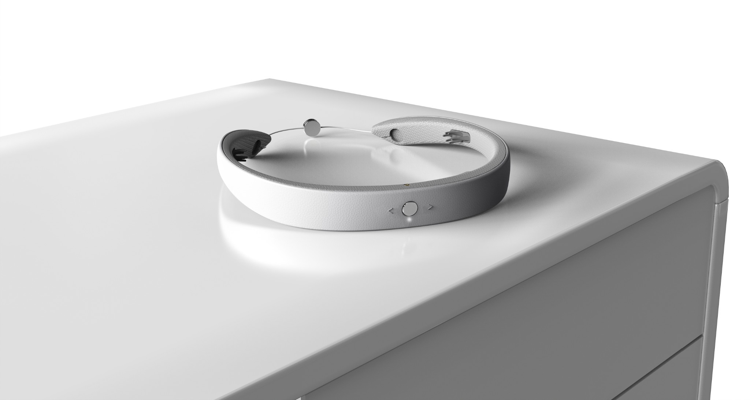
Earable® Neuroscience US is a deep tech company delivering scalable, human-centric solutions that improve the everyday experience – from deep sleep to all-day focus, relaxation, meditation, and other neuroscience-based potentials.
FRENZ™ Brainband by Earable® is the world’s first AI-powered sleep tech wearable that can track and stimulate brain activities via bone-conduction speakers to facilitate better quality sleep, focus, and relaxation.

Vision: To make the daily advantages of neuroscience accessible to everyone, everywhere through improved sleep quality, enhanced cognitive functions, and unlocked brain power.

FRENZ™ is the first AI-powered brainband ever to interact with the brain based on precise neurofeedback signals, using scientifically proven audio techniques to enhance sleep (other trackers on the market measure limited data sets with less precision and provide limited personalized audio stimulation):
- Precisely track several vital data points (EEG - brain signal - filtered into brain frequencies of Delta, Theta, Alpha, Beta, Gamma, EOG - eye movement, EMG - micro facial movements, SpO2, hear trate..) in real-time.
- Provide instant personalized feedback with cognitive behavioral therapy (CBT) content for users to adjust and improve their cognitive functions via its integrated bone-conduction speakers.
- Leverage deep machine learning to provide meaningful insights (sleep portrait, focus portrait, …).

Priced at $490 USD, FRENZ™ is:
- 100x more affordable than a month in a sleep lab (Around $100K for a professional PSG device set).
- It does not require a trained technician at $2K a day to operate.

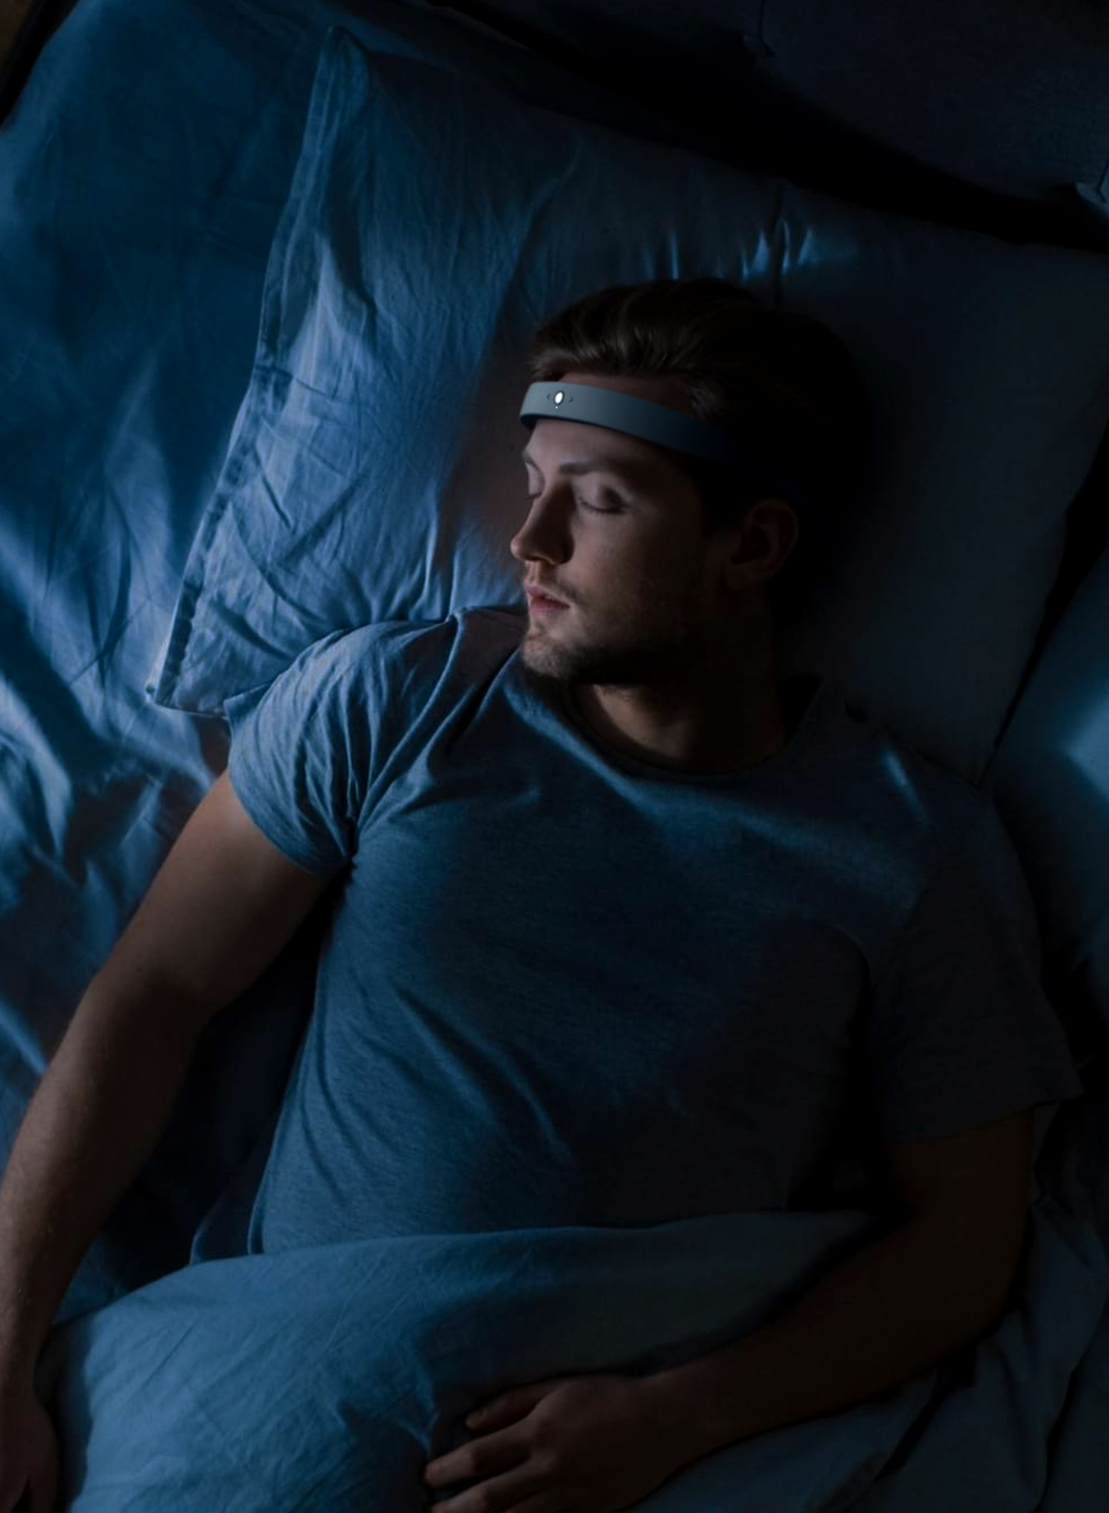
What the tech measures
In real-time, FRENZ™ tracks the following 7 vital signals:
- Brain signal - Electroencephalogram (EEG) is a recording of brain activity via sensors to pick up electrical signals produced by the brain.
- Eye movements - Electrooculography (EOG) is a technique for measuring the crone-retinal standing potential between the front and the back of the human eye.
- Facial Muscle signal - Electromyography (EMG) is a diagnostic procedure to assess the health of muscles and the nerve cells that control them (motor neurons)
- Oxygen level - Spo2 measures the amount of oxygen affixed to hemoglobin cells within the circulatory system.
- Heart rate - The number of times the heart beats within a certain period.
- Head motion and position – Provides accurate information about sleep position.
- Breathing rhythm – Used for breathwork and respiratory monitoring.

How it works
Earable’s mechanical engineering team and electrical-circuit experts engineered a proprietary low-noise electrical integrated system that captures signals precisely, eliminating noise caused by the wearer's movements. FRENZ™ applies patented ML algorithms to filter, split, and process multiple signal channels to activate appropriate acoustic stimulation at precise moments.

Using advanced nano-material science, FRENZ™ is designed to be worn daily and nightly comfortably. In addition, FRENZ™ integrates behind-the-ear bone-conduction speakers inside innovative sound chambers to withstand head pressure and avoid sound distortion. The device's over-ear dry-sensing electrodes (FrenzTouch) are strategically placed at optimal locations to track and reference strong signal sources amidst noise.
FrenzTouch, made of a proprietary perfect-ratio mixture of nanomaterials under a special curing process, has flawless conduction while maintaining comfort in any sleeping position.

Besides monitoring, FRENZ™ administers ongoing personalized clinically-proven cognitive behavioral therapies. After rigorous clinical trials involving 1,250 subjects over 2,100+ sleep sessions, conducted over six months at Earable’s Sleep Labs, FRENZ™ has proven effective in reducing average sleep onset by 19 minutes. Complete findings can be viewed here.

Key Features
SLEEP
- Sleep Portrait: logging complete data of your daily sleep
- Sleep Coach: personalized feedback and suggestions for improvement
- Deep Sleep: continuously adjusted content coupled with real-time data insights to quickly get you to the deep sleep stage
- Power Nap: Set your nap duration and go for a fast, deep, effective nap break to refresh your brain
- Fresh Morning: Wake up refreshed while FRENZ™ identifies the optimal time during your sleep cycle to wake you up timely

FOCUS
- Focus Portrait: logging complete data of your daily working hours and brain activities
- Focus Coach: personalized feedback and suggestions for improvement
- Focus Mode: quick session to boost your concentration, ideally for learning or problem solving

RELAX
- Vast library of curated professional content to help users feel relaxed
- Coming soon: relaxation scoring system

The App
The minimalist app is designed to be intuitive. As smartphones have become a leading source of distraction, FRENZ™ lets users avoid screen time by seamlessly interacting with the app using only voice recognition.

Simply say, "let's sleep," and the app uses integrated AI/ML and cognitive behavioral therapies to create the best personalized experience throughout the night. When needed, the user can find the dashboard with sleep and focus indexes, where complex data is distilled and visualized into easy-to-read metrics to coach sleep improvements.

Technical Specs
- L x W x H: 6.5 x 6.2 x 0.86”
- Weight: 3.17 oz
- Proprietary patent-protected technologies for dry sensing conductive nanomaterial
- Real-time measure of EOG, EEG, EMG, SpO2, head motion, and breathing rhythm
- Ergonomic bone-conducting audio to deliver personalized audio content in real-time to stimulate brain activities
- Machine learning and AI-enabled personalized real-time stimulation
- Medical grade materials and ergonomics designed to maximize comfortability, aesthetics, and functionality

Awards & Recognition Investors
---

The Team at Earable Neuroscience US
Earable Neuroscience is a deep tech company delivering scalable, human-centric solutions to improve the everyday experience. The company was founded by Dr. Tam Vu, a dedicated scientist and innovator who is currently a Professor at the University of Colorado. After eight years of deep tech R&D, the team has grown to include 60 passionate talents with expertise in neuroscience, artificial intelligence, and machine learning.
Earable has garnered support from partners worldwide, with funding from Smilegate Investment, 500startups, and Founder’s Fund - Peter Thiel’s legendary venture capital known for its specialized investment portfolio focusing on revolutionary tech companies.

The company’s first product, FRENZ™, has won 8 global awards, and holds 15 patents and patent-pendings in machine learning algorithms, material science, and electrical engineering.

The company is now in the final stage of commercializing this consumer wellness tech lifestyle to help improve the world’s mental state by enabling an entirely new world of possibilities for neuroscience applications through the company’s neuroscience data platform.

Timeline
- 2019: Filed patent for patented IE/IC System
- 2022: Granted patent for signal separation (ML & AI)
- 2020: Won a 2020 Sloan Research Fellowship for computer science
- 02/2018: Won a Google Research Award
- 2016 + 2019: Won Best Research Paper awards at the Association for Computing Machine Conferences
- 10/2022: Won VMARK's Gold Product Innovation Award
- 10/2022: Won the 2022 TOP AI INNOVATION AWARD from GITEX GLOBAL’s Supernova.
Challenge
- 10/2022: Mobicom Technology Co-Chair and Earable Day Organizer
- 11/2022: Won the CES Innovation Award in the Wearable Technologies Category (Announced at CES
Unveiled New York)
- 01/2023: FRENZ by Earable® Global Launch Day at CES 2023
- 01/2023: Pre-orders start globally
- 03/2023: Pre-order campaign on a crowdfunding platform
- 04/2023: Global deliveries of the first batch of FRENZ™ Brainband

--
This Media Backgrounder was prepared for the purpose of internal circulation only for CES event. Media contact: media@earable.ai

