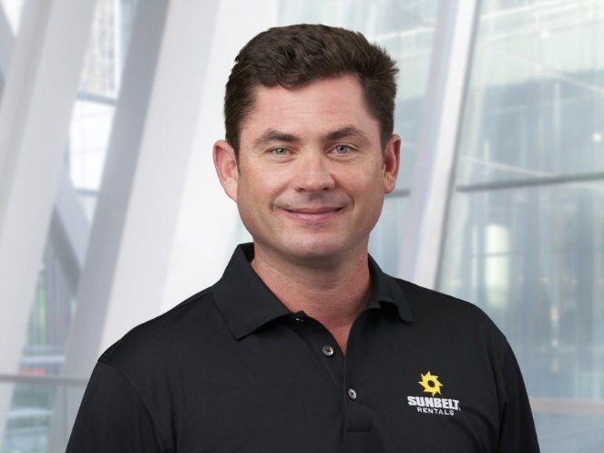

**Brendan Horgan, Chief Executive Officer**

*Sunbelt Rentals*

Brendan Horgan has been part of the Sunbelt Rentals team since 1996, bringing 25 years of experience and detailed knowledge of the organization in his role as chief executive officer.

Brendan joined Sunbelt Rentals after receiving his bachelor’s degree in business and has worn many hats during his long career with the company.

Advancing to chief operating officer in 2003, he subsequently led the substantial growth of the organization with a very talented team.

Brendan became CEO of North America in 2011 as well as being named a director of Ashtead Group plc.

In 2019, Brendan went on to assume the role of chief executive for Ashtead Group plc.

**John Scannell, Chairman and Chief Executive Officer**

*Moog Inc.*

John Scannell joined Moog Ireland in 1990 as an Engineering Manager and later moved to Germany to become Operations Manager of Moog GmbH.

In 1999, he became the General Manager of Moog, Ireland, and in 2003 moved to the Aircraft Group as the Boeing 787 Program manager and was subsequently named Director of Contracts, Pricing and elected a Vice President of the company in 2005.

He was elected Chief Financial Officer in 2007, a position he held until December 2010, at which time he was elected President and Chief Operating Officer.

In December 2011, Mr. Scannell was elected Chief Executive Officer and was named Chairman of the board in January 2011. In addition to an M.B.A. from the Harvard Business School, Mr. Scannell holds a BS and MS in Electrical Engineering from University College Cork, Ireland.

Mr. Scannell has been a Director of Albany International Corporation since 2012. He became a Director of M&T Bank in 2017.