CONTACT: Lisa McKendall
lisa@tosechinc.com
(310) 641-1556

TOSECH, LLC
Company Backgrounder

Sometimes Los Angeles traffic can change your life – positively. Take Tim Wills and Ryan Mansour, founders of TOSECH. They were both stuck in typical Friday evening gridlock and began a phone conversation that resulted in a time and resource commitment to build a new company that leverages their prior business experience in family consumer segments.

As a result, in early 2018, TOSECH was incorporated with a simple business plan and team mission to deliver innovative solutions and/or enhancements to ordinary, mundane consumer product categories and experiences. This was a result of an agile and pragmatic organization founded on seasoned global talent and consumer insights. Even with decades of experience, the team acknowledges that beginning a start-up journey with healthy levels of confidence, expertise, energy, work ethic and some naivety never prepared them for every challenge, but these strong attributes were critical to taking the dive and problem-solving for the unexpected!

Their first key step was identifying a core of human assets to help them make their vision a reality. With the objectives of working with proven, experienced, fun, talented people and partners, Tim and Ryan reached out to close business friends and associates to invite them to join the TOSECH adventure. The collective team immediately set to work to help refine and build on existing plans and to launch the first strategic business unit of TOSECH, Smartē.

Smartē is focused on the consumer electronic family segment and will deliver accessories and solutions to support smart home/life devices and experiences. With privacy and safety concerns surrounding smart speakers in the home top-of-mind, the first product to launch from the Smartē team is Mute , a battery operated, smart speaker noise canceling device scheduled to launch in Spring 2019.

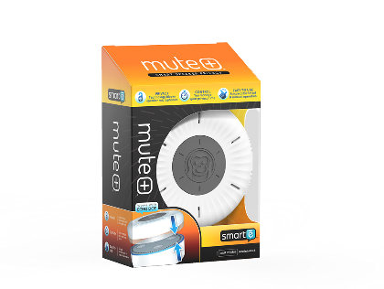
Mute provides an answer to privacy concerns by simply connecting to the top of Amazon Echo, Echo Plus and Echo Dot smart speakers allowing the proprietary noise dampening technology to temporarily block the speaker’s microphones and thus the potential recording of, or eavesdropping on, private conversations. The patented technology fits easily on top of a smart speaker device and cancels any noise input to the microphones. Mute+ can be left there and manually turned on and off when needed without any interference to the speaker. The device also includes a lighted privacy timer that can be set for increments up to an hour at a time. The durable, sleek design coordinates with most décor and provides a fun opportunity to accessorize a smart speaker.
####

