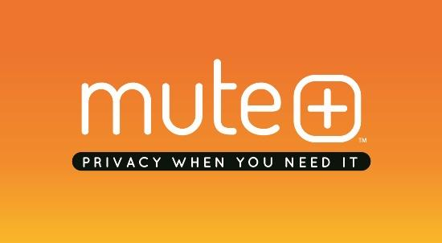
Media Contact: Lisa McKendall
Lisa.mckendall@tosechinc.com
310-641-1556

MUTE
Fact Sheet

What: Privacy is a meaningful and valid worry when it comes to using a smart speaker. The Mute ™ from Smartē™ provides a simple solution to help these concerns by easily connecting on top of select Amazon Echo, Echo Plus or Echo Dot smart speakers and creating an extra layer of trusted protection to enhance your experience.
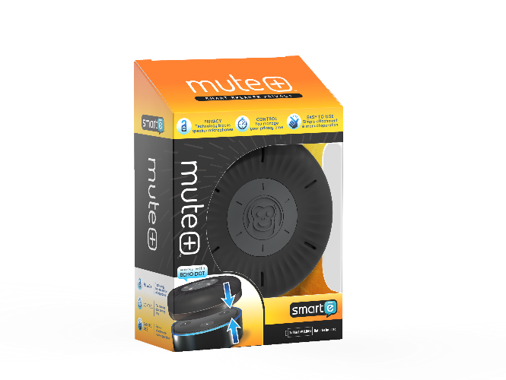
Mute uses proprietary air dampening technology to temporarily block any noise near or far from the smart speakers’ microphones. In addition, the six lighted timer settings can be set for up to an hour at a time. The portable, battery operated Mute fits easily on top of the smart speaker and can be left there without any audio or visual speaker interference and turned on only when you need it. The durable, sleek design coordinates with most décor and provides a fun way to accessorize or personalize your smart speaker.
The Mute ’s multi-device design allows it to work with the Amazon Echo, Echo Plus and Echo Dot.
Where: The Mute will be available at www.mysmartelife.com as well as other select online and brick and mortar retailers.
When: The Mute will be available in Spring 2019.
Who: Smartē is a division of TOSECH, LLC., a dynamic company powered by a team determined to re-imagine the ordinary through insights, innovation, creativity and product narrative to deliver savvy home and life upgrades in a variety of mundane consumer segments.

######

