SOLUS STREAMAV 5.2 THEATER SYSTEMS HITS THE MARKET

Perfect for Condos, Hotels and High Rise Developments
Las Vegas, NV – CES 2017, January 03, 2017 – Solus Audio is proud to announce its new brand, Solus StreamAV, a complete 5.2 Home Theater Speaker System built-in to an acoustically designed furniture cabinet that fits perfectly beneath any TV screen.
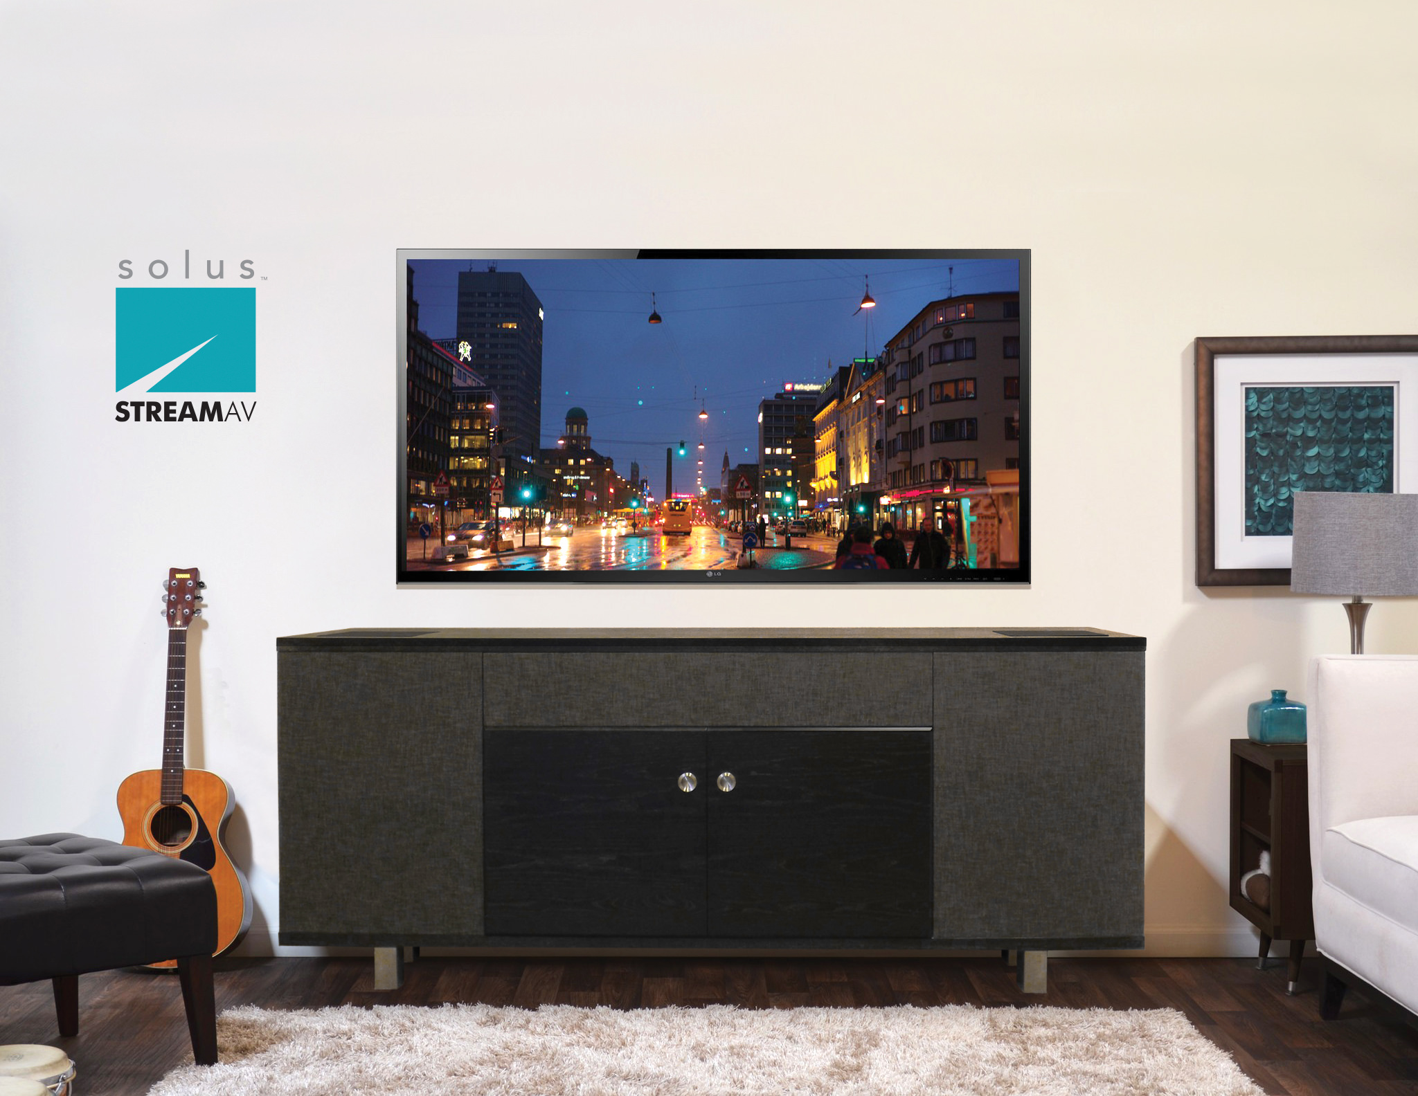

StreamAV (shown in Charcoal Grille Covers)

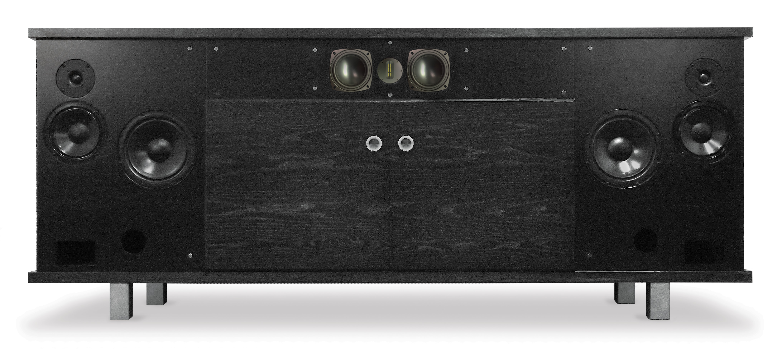
StreamAV (shown without Grille Covers)
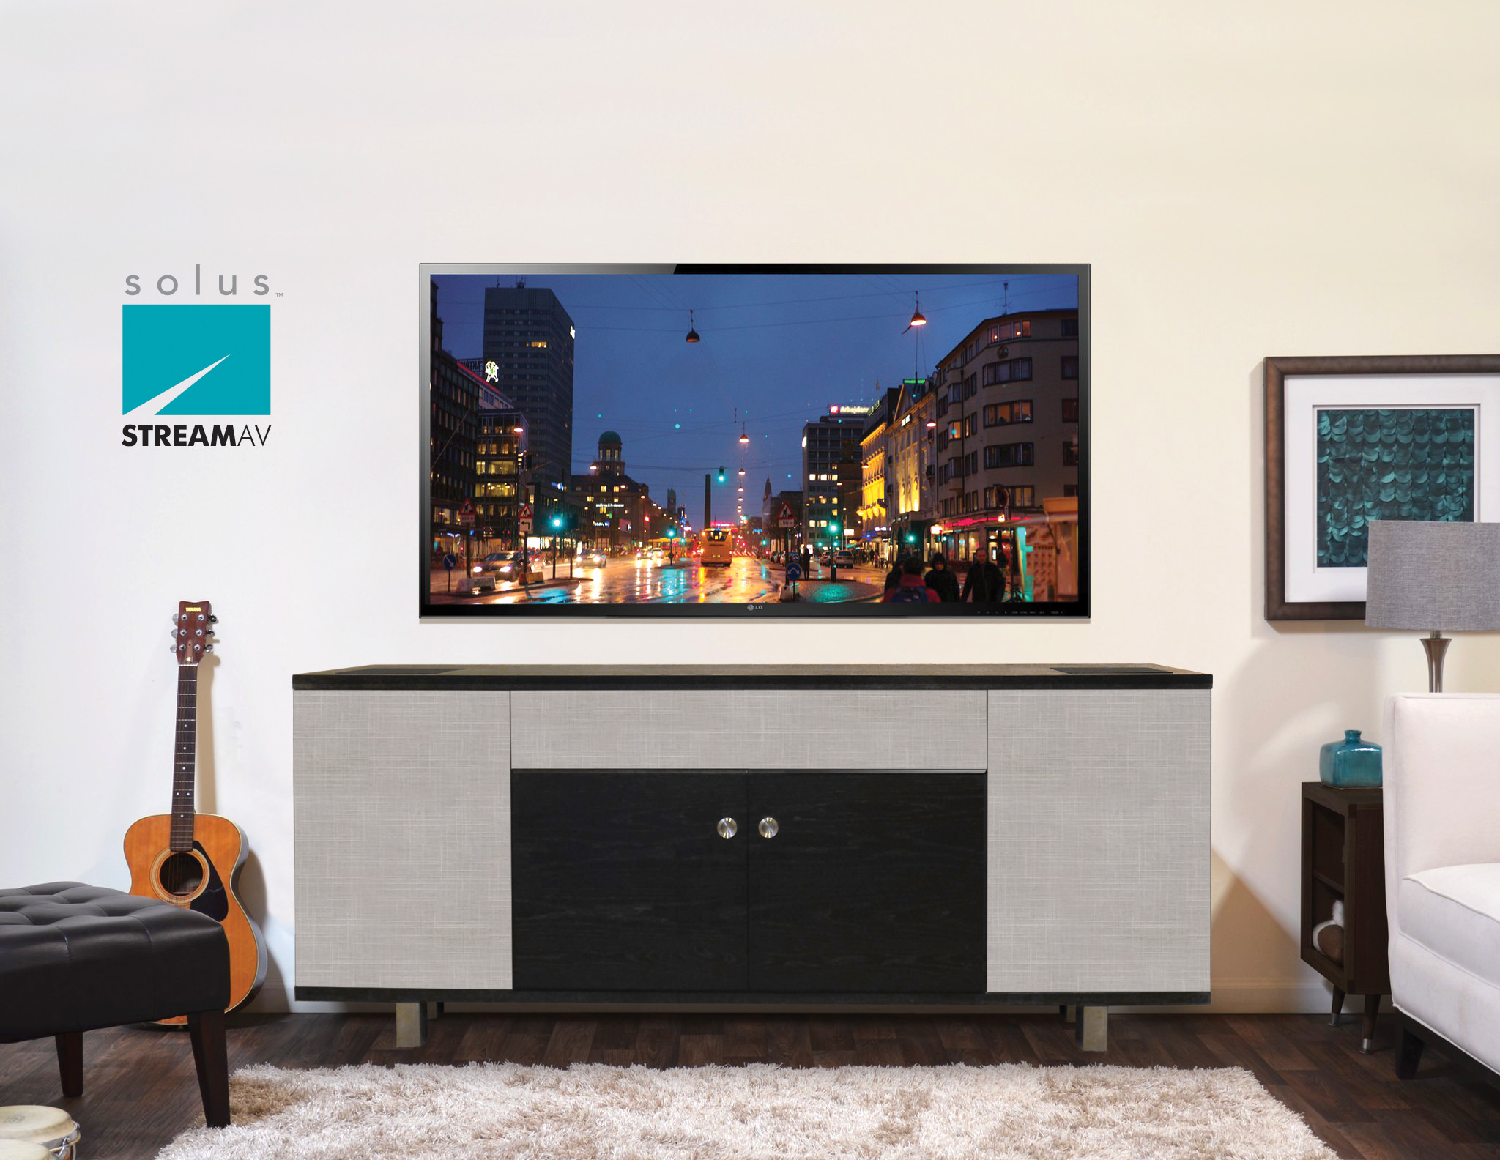
StreamAV (shown without Grille Covers)
Solus StreamAV isn’t your Father’s 1970 stereo console by any means. What is it? –StreamAV is a revolutionary 5.2 home theater system where the speakers are built-into a perfect compact environment (its own cabinet), and fine tuned making it simple for dealers, installers to sell, set-up and deliver, operate and even move, if necessary. Its modular all-encompassing design is a monumental step forward in making high-performance home theater simplistic, compact and affordable. Solus StreamAV is a turnkey solution for luxury high-rise residential condominium clientele and five-star hotel developments where entertainment amenities are top notch as well as outstanding AV performance for single-family home use.

Measuring only 6’ wide, 19” deep, and 26” tall, the sleek modern cabinet takes up considerably less space than most AV furniture. Yet, it will accommodate up to an 80” TV without any overhang for a clean aesthetic appearance. Yet, no speakers or gear is visible to the eye from its exterior – the room décor is clean, elegant and uncluttered.

StreamAV is a powerhouse audiophile home theater speaker system built with patented technology and modern cabinetry to deliver the perfect acoustic theater performance – just add your preference of source (Audio/Video Receiver, DVD, Cable/SAT). As a complete 5.2 Dolby Digital Speaker System already, StreamAV is enabled for Dolby Digital Atmos® 5.2.2 system by simply adding an Atmos AV receiver and wireless rear surrounds.
For left and right front speaker channels the StreamAV features a proprietary 6.5" woofer with 1.5" high output, high transient response voice coil woofers with patented, I-PAShd bass loading technology with a 1", liquid cooled silk soft dome in a fast, wide frequency range two-way speaker system for superb, clean, extended low bass and extraordinary low bass dynamics.

The center channel includes dual 4" aluminum cone high X-max "full-range" drivers and a 4" planar magnetic ribbon tweeter in its own sealed enclosure for outstanding clarity.

For the extreme low bass are two long throw vented cabinet 8" woofers, again in their own and separately engineered cabinets, each with a response down to the mid 20-Hertz range. Having two of such subs helps smooth out the room response even more while also covering more area, large areas included. Solus makes available for powering the two subwoofers a special amp that fits right into StreamAV shelf equipment area large enough for 6-7 equipment components if desired.

There are also two left and right speakers on angle at the top of each end of the StreamAV, each with dual full-range 3" aluminum cone drivers. Requiring no crossover eliminates power loss due to crossover inductance and allows for no electrical phase shift in the sound. The results are greater output, more clarity and improved environmental stage. Add the speed and clarity of the 4" planar magnetic ribbon tweeter and the total environment sound of the StreamAV is simply "you are there" extraordinary with hair raising dynamics.

StreamAV is designed, created and backed by two leading technologists – Philip Clements, president of Solus/Clement Loudspeakers of the U.S. and StreamAV engineer and Tony Daly, a renowned furniture designer of Canada. Philip is the patent holder for I-PAShd. extended low bass speaker technology featured in the StreamAV 5.2 system5.2 and 5.2.2 system.

MSRP pricing is $5,999. and includes the amplifier from Solus for the built-in subwoofers, with availability in the second quarter, 2016. Several wood veneer finishes with multiple variations of coordinated grills covers are available

Visit Solus Audio at CES The Venetian, 29th Floor, Suite 220 during show hours at CES 2017. CES press conference Friday, January 6, 2017 at 10:00a.m. at The Venetian – Suite 29-220.

# # #

ABOUT SOLUS AUDIO – www.solusaudio.com
Solus Audio designs, manufactures, and distributes loudspeakers for home theater, general sound, and whole house audio. They include architectural in-wall/ceiling, and classic cabinet - bookshelf, floor standing and powered subwoofers. Philip Clements, inventor and patent holder of H-PAS technology, has advanced such now known as I-PAShd. Solus Audio is proud to announce its new brand, Solus StreamAV at CES 2017 and I-PAShd technology.
Solus AV Stream Contact: Philip Clements, President • 1 (602) 574-7729 • email: phil.solus@cox.net
Sean Miller, General Manager • 1 (602) 437-4445 • email: solusaudio@gmail.com
Press Contact: Roberta Lewis • Tel: 1 (713) 408-9401 • email: roberta@robertalewis.com
All rights reserved. All brands and trade names are the property of their respective owners.

