Omron® Healthcare Digital Health Ecosystem:
Omron Connect and the NEW HeartAdvisor™

Omron Healthcare connected devices pair with our mobile apps so users can store their data, track it over time and share it with their doctor to optimize treatment. Regular blood pressure monitoring and acting on that data is the path to managing hypertension and saving lives – it’s one of the ways Omron is Going for Zero heart attacks and strokes. The NEW HeartGuide™ from Omron, the first wearable blood pressure monitor, pairs exclusively with their NEW HeartAdvisor digital health service. All other Omron connected devices, including the NEW Complete™ (blood pressure + EKG) and Evolv® (upper arm blood pressure monitor) are compatible with the Omron Connect™ app.

Omron HeartGuide syncs exclusively with the HeartAdvisor app, an insights-driven digital health service that helps users understand their condition and take action on their heart health readings.

- Those who own the Omron HeartGuide gain exclusive access to the Omron HeartAdvisor digital health service.
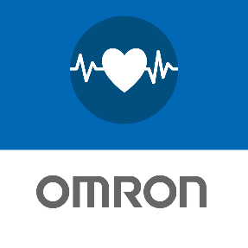
- HeartAdvisor tells a user what a blood pressure reading means and what to do about it. Getting enough sleep? Higher stress posing a higher risk? HeartAdvisor provides insights and helps a user take action on the data. Omron created HeartAdvisor to encourage regular monitoring and to teach positive heart health behaviors.

- HeartAdvisor stores and tracks blood pressure, daily activity (including steps, distance and calories burned), pulse rate and sleep quality to share with users’ physicians. This data can be used for better treatment and better outcomes.

- HeartAdvisor calls attention to higher-than-normal readings and empowers a user with direction to help decrease risk of heart attack or stroke.

Omron Connect app syncs with connected Omron heart health devices, including Complete™ Blood Pressure Monitor + EKG and Evolv® devices – enabling a user to conveniently store blood pressure readings, track numbers over time and share data with a healthcare provider.

- Stores blood pressure, EKG and heart rate data in one place, to provide a more complete picture of a user’s heart health.

- Equipped with an easy to navigate, intuitive dashboard that conveniently charts and graphs data – viewable by day, week, month or year – for easier and unlimited monitoring of your personal heart health trends.

- Displays high readings, empowering users to monitor and decrease their chance of a heart attack or stroke.

- Omron is the first blood pressure monitor brand with an interactive Amazon Alexa skill. With the Omron Connect App and an Omron connected device, a user can ask Alexa to open their app, locate and read back their latest blood pressure reading and set reminders to monitor their blood pressure. The Omron skill for Alexa can also compare readings and calculate averages across different dates and times of day, and flag high readings.

- Available on Apple iTunes and Google Play stores. The iOS version shares data with Apple Health.

