HeartGuide™ Wearable Blood Pressure Monitor (BP800M)

HeartGuide™ is the first wearable blood pressure monitor in the compact form of a wrist watch – for those who want to keep watch on their heart health, anywhere and take action for their heart health.

- The sleek and stylish HeartGuide™ uses an inflatable oscillometric blood pressure cuff -- the same technology used in a doctor’s office -- to ensure accurate and reliable readings.

- HeartGuide® received 510K FDA clearance as a medical device.

- HeartGuide® accurately measures blood pressure, daily activity (including steps, distance and calories burned), pulse rate and sleep quality. It also functions as a smartwatch, where users can receive text, call and email notifications.

- Omron has filed has more than 80 new patents for the innovations and new technologies developed to create HeartGuide® in the compact form of a wrist watch. Some of the pumps and valves in HeartGuide® are no larger than a grain of rice.

- HeartGuide® holds up to 100 measurements in memory and connects exclusively with Omron’s new HeartAdvisor™ app, which stores and tracks heart health data and provides insights and personalized coaching to help users take action for their heart health.

- A typical user can expect to charge HeartGuide approximately 2-3 times per week, depending upon the frequency of use of HeartGuide®’s features.

- Currently available in size medium (fitting 75% of individuals); small and large sizes will be available later this year.

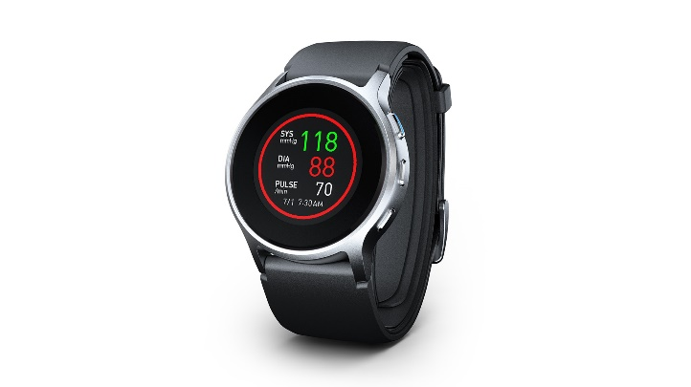

Specifications | Diameter approximately 1.89” (48 mm)  Case thickness approximately 0.55” (14 mm)  Band width approximately 1.18” (30 mm)
Availability & MSRP | OmronHealthcare.com; $499 (USD)
Media Contact | MWWPR for Omron Healthcare / Katherine Clark / 312.981.8548 / kclark@mww.com
More Information | https://omronhealthcare.com/heartguide-wearable-blood-pressure-monitor-bp8000m/
*High-res images available upon request

