Complete® Blood Pressure Monitor and EKG Device

Complete® is the first all-in-one blood pressure monitor with EKG capability in a single device for home use in the U.S, providing a more complete heart health picture.

- Up to six million Americans have atrial fibrillation (AFib) and their stroke risk is five times higher. Complete® has the unprecedented ability to monitor two critical risk factors for stroke – AFib and high blood pressure – together at home with a single device.

- Intuitive and user-friendly, Complete® syncs with the Omron Connect mobile app. Blood pressure and EKG readings can be stored, tracked and shared with your doctor to gain more insights and improve treatment over time

- Developed with AliveCor, the market leader in FDA-cleared EKG technology

- Allows for concurrent at-home monitoring of atrial fibrillation and hypertension – two of the leading causes of stroke

- Detects normal heart rhythm or atrial fibrillation in approximately 30 seconds
- Identifies atrial fibrillation in patients with intermittent symptoms as well as asymptomatic, high-risk populations

- An at-home EKG and blood pressure monitoring device from the #1 doctor and pharmacist recommended blood pressure monitor brand

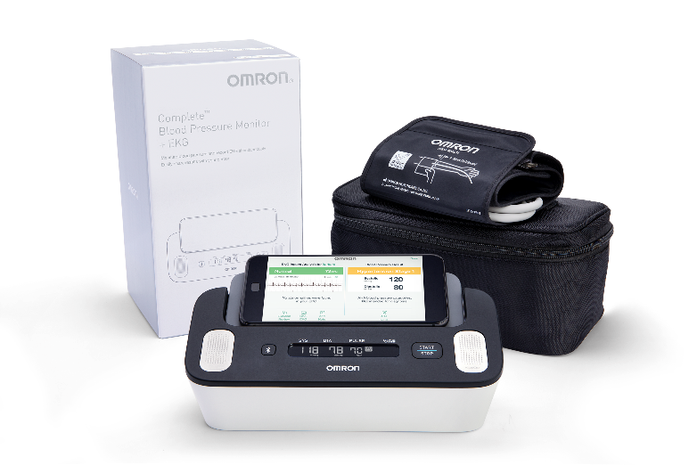

Specifications | Monitor: Approximately 9.1" (w) × 3.9" (h) × 4.8" (l) (232 mm × 98 mm × 123 mm)  Arm cuff: Approximately 5.7" × 23.4" (air tube: 29.5”) (145 mm × 594 mm (air tube: 750 mm)
Availability | OmronHealthcare.com, 2019 availability
Media Contact | MWWPR for Omron Healthcare / Katherine Clark / 312.981.8548 / kclark@mww.com

*High-res images available upon request

