MEDIA INQUIRIES ONLY CONTACT:
Christine Azzolino/Jennifer Samuels
Coyne Agency
(973) 588-2000
cazzolino@coynepr.com
jsamuels@coynepr.com

S. Vander Schans/ A. Colasacco
CASIO AMERICA, INC.
(973) 361-5400
svanderschans@casio.com
acolasacco@casio.com

CASIO TO RELEASE SECOND NEW SMART OUTDOOR WATCH WITH GPS TO INSPIRE USERS TO VENTURE EVEN FARTHER AFIELD

Comes with a Variety of Original Apps That Make the Most of Color Maps
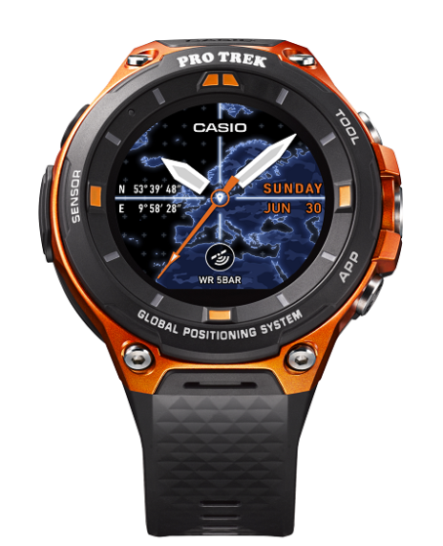
WSD-F20

LAS VEGAS, January 4, 2017 — Casio Computer Co., Ltd. announced today that it will release the second product in its Smart Outdoor Watch category of wrist devices featuring water resistance and tough performance for outdoor activities. The new WSD-F20, which is scheduled to be released on the 21st of April, will run Android Wear 2.0*, and is equipped with low-power GPS and new color map functionality that can be used offline to expand the range of outdoor adventures.
* The previous model, the WSD-F10, will also adopt Android Wear 2.0 in the spring of 2017.

In March 2016, Casio released the Smart Outdoor Watch WSD-F10 with a rugged build and dedicated apps for outdoor activities. The WSD-F10 has been well-received as a truly practical wrist device that delivers the unique advantages of a wearable device for the outdoors.

The new WSD-F20 is equipped with low-power GPS and color map functionality that can be used offline, significantly improving its usability as a standalone wrist device. It supports a wide range of outdoor and water activities and can be used in areas without cellular service, freeing up users to fully enjoy their adventures. The WSD-F20 now incorporates richly-designed and easy-to-read map data from Mapbox, which is used worldwide. Maps can be downloaded in advance to the WSD-F20 and used with GPS data to track the user’s location, even when offline. The new Location Memory app enables users to customize maps by adding markers and text, so that they can revisit otherwise unmarked spots such as a great viewpoint on a hike or a good fishing spot.

In terms of design, button guards, a protective bezel, and side buttons of varying sizes enhance operability and toughness, making the WSD-F20 an even more useful piece of outdoor gear.

The WSD-F20 enables quick access to the information during activities, such as trekking, cycling, fishing, winter sports, and watersports. This watch allows users to keep their hands free and fully enjoy outdoor activities.

The WSD-F20 is positioned in the PRO TREK Smart series, the latest addition to the PRO TREK brand of outdoor watches by Casio that are designed for total appeal to outdoor enthusiasts.

Model | Color
WSD-F20 | Orange / Black

Main Features of the WSD-F20

Original outdoor apps utilize low-power GPS and color maps that can be downloaded for offline use
The WSD-F20 is equipped with low-power GPS to track the user’s current location without depending on a smartphone. It also features color map functionality that can be used without any kind of cellular or internet connection, simply by downloading the maps in advance. Casio has developed various original apps that make the most of these two functions in the outdoors, allowing users to track their location on a map or add notes to a map.

■ Location Memory
This app instantly reads the user’s current location, and is directly accessed by pressing a side button. In addition to recording the path traveled, users can make a mark or use speech recognition* to add notes to otherwise unmarked map spots, such as a great viewpoint on a hike or a sweet fishing spot. Navigation and Reminder functions are useful when revisiting a location that has been noted on a map. The user can also choose from a variety of map designs based on what they are doing and what they are using the maps for.
*Speech recognition cannot be used without cellular service on a smartphone

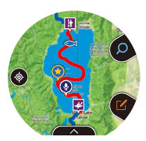 |  | 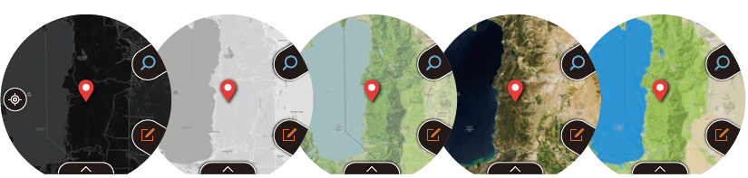
Add markers to a map | Examples of the many marks for use on maps | Variety of map designs  ©Mapbox ©OpenStreetMap

■ Activity
The Activity app displays real-time measurement data and has special functions for activities such as hiking, cycling, fishing, and snow and paddle sports. Now significantly upgraded, the app can use GPS data and color maps in the Hiking function to record the path traveled on a map, while also showing the course and maximum speed of each run in the Snow function.

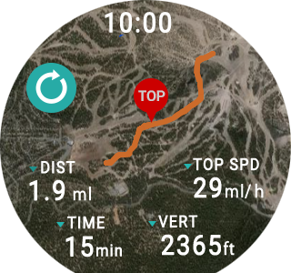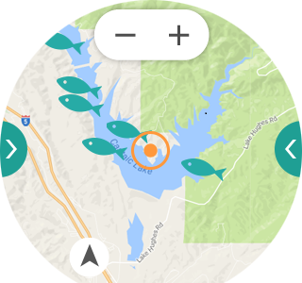
©Mapbox ©OpenStreetMap
■ MOMENT SETTER
This app alerts the user to important moments while they are hiking, cycling, fishing, or enjoying snow or paddle sports. The user sets conditions to automatically receive important alerts, such as best fishing times, rest break intervals, and sunrise/sunset times.

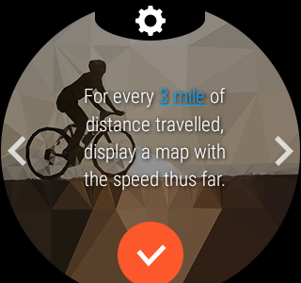 | 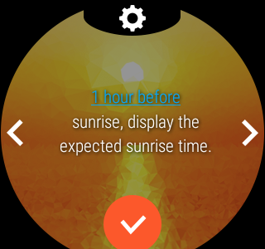 | 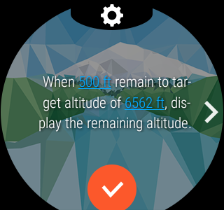
TOOL app measures various kinds of data to track environmental changes and show user activity levels
The WSD-F20 comes with an original app that measures and displays essential information for outdoor activities and sports using a pressure sensor, compass, and accelerometer. The app provides real-time information about changes in the natural environment and the user’s activity levels, such as compass direction, altitude and air pressure, sunrise and sunset times, tide graphs, and activity graphs.

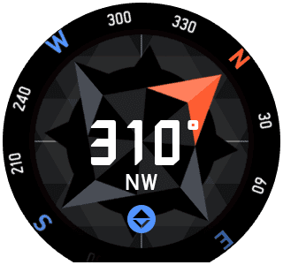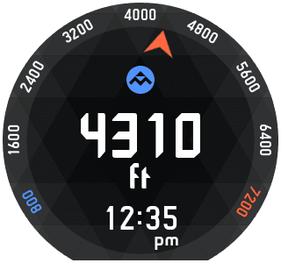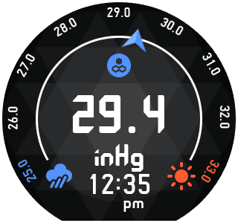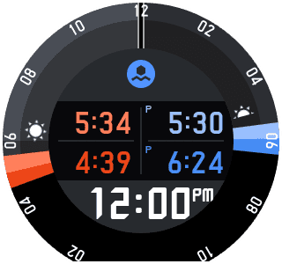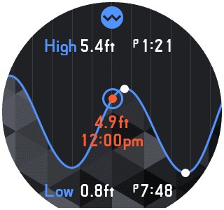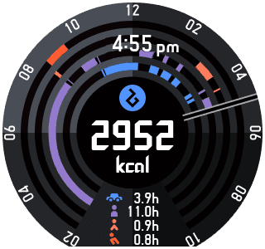
Compass Altitude Air pressure Sunrise/sunset Tide graph Activity graph

Proprietary dual-layer LCD comes with power conservation mode
The WSD-F20 features the same style of dual-layer monochrome and color LCD that was so well-received in the WSD-F10. The monochrome LCD shows the time while the color LCD shows maps, measurement data, and apps. The watch can switch on both LCDs, or just the monochrome LCD, to ensure optimum visibility in all situations and conserve power when spending long hours in the outdoors.

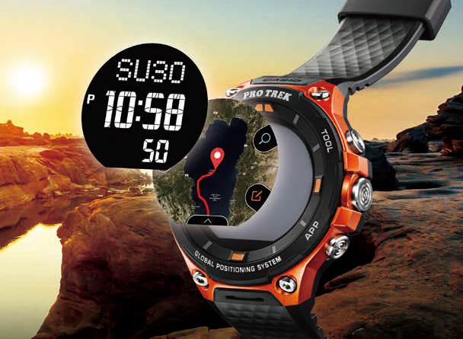 ©Mapbox ©OpenStreetMap

Interchangeable Original watch face designs enhance appeal
Location and Traveler are new watch face designs that utilize GPS functions and map data. Location highlights GPS and map functions with sophisticated animations on the map display. Traveler enables the user to switch the type of information displayed in the window in the lower part of the watch face, and to launch the corresponding app just by tapping the watch face. Not only these two, the watch comes pre-installed with various faces to choose from for outdoor or everyday use, and even more watch face designs can be downloaded and added from the Google Play store.
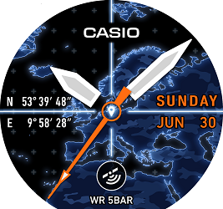  Location | 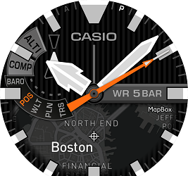  Traveler
©Mapbox ©OpenStreetMap
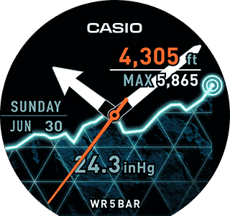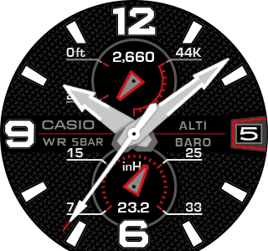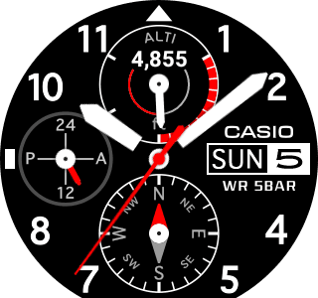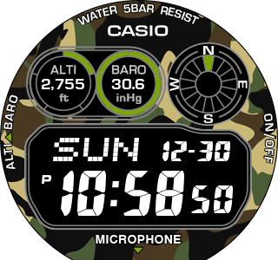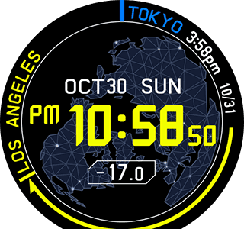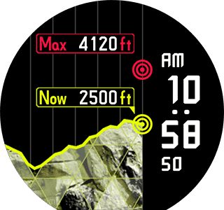

Toughness meets outdoor challenges

■ Water resistant to 50 meters
The watch is water resistant to 50 meters yet equipped with a water-resistant audio mic, for everyday use as well as in rain and even during water activities such as kayaking. The touchscreen features a new anti-fouling coating to resist stains from fingerprints.

■ Built to military standard specifications
Tested to United States military standard MIL-STD-810 issued by the U.S. Department of Defense to perform in the rugged outdoors. Meets testing requirements under various environmental conditions including shock and vibration.

Additional apps enhance the outdoors experience

■ CASIO MOMENT LINK location-based communication app
This app displays the current location of group members on a color map, enabling users to exchange text messages. This fun and useful app is great for communicating with a group of friends, such as when fishing at different spots or cycling at a different pace.
*This app uses the cellular connection and GPS data on a smartphone. The app cannot be used without cellular service and GPS reception on your smartphone. Connection to iOS device not supported.

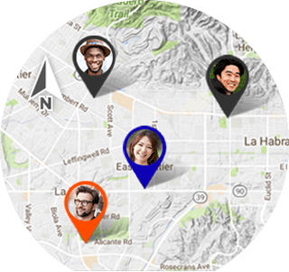

Link to other apps popular with outdoors enthusiasts
The following outdoors apps can be optionally installed by choosing Casio Recommended from the App List screen on the watch.

■ ViewRanger GPS app for hiking
This is a GPS app for outdoor adventurers providing route information, navigation guidance, location data and distance to next waypoint all at a glance. App by Augmentra Ltd.
http://www.viewranger.com/

■ MyRadar weather app
This real-time weather app shows local animated weather maps, helping the user to easily and quickly track weather changes nearby. App by ACME AtronOmatic, LLC.
http://myradar.acmeaom.com/

■ YAMAP GPS app for hiking
This GPS app can display hiking maps even without cellular service. YAMAP is widely used by outdoor enthusiasts and has won numerous awards for its novel features and utility. App by YAMAP Inc.
https://yamap.co.jp/

Available colors
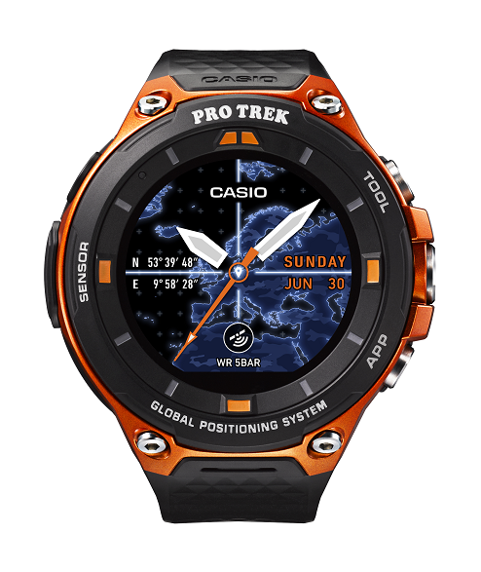  Orange | 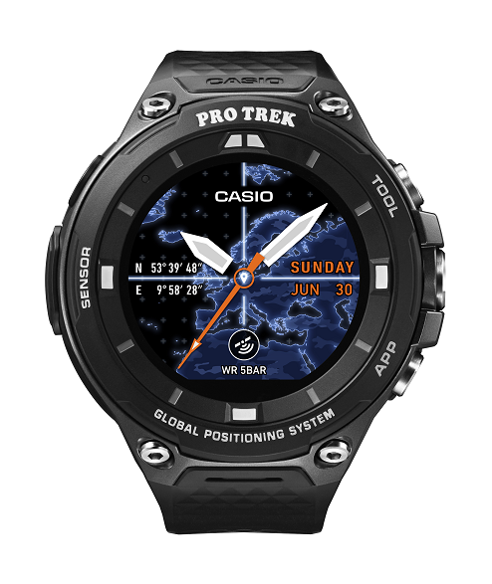  Black

Smart Outdoor Watch Official Website:
http://wsd.casio.com/

Main Specifications of the WSD-F20
Water Resistance | 50 meters^{*1}
Environmental Durability | MIL-STD-810 (United States military standard issued by the U.S. Department of Defense)^{*2}
Display | 1.32-inch dual layer display  Color TFT LCD and monochrome LCD  Color: 320×300 pixels
Touchscreen | Capacitive touchscreen (anti-fouling coating)
GPS | Compatible (including GLONASS^{*3} and Michibiki)
Color Maps | Compatible (supports offline use)
Sensors | Pressure (air pressure, altitude) sensor, accelerometer, gyrometer, compass (magnetic) sensor
Microphone | Yes
Vibrator | Yes
Wireless Connectivity | Bluetooth® V4.1 (Low Energy)  Wi-Fi (IEEE 802.11 b/g/n)
Buttons | TOOL button, Power button, APP button
ｓBattery | Lithium-ion battery
Charging Method | Magnetic charging terminal
Recharging Time | Approx. 2 hours at room temperature
Battery Life | Normal use: more than 1 day, roughly (varies according to use)  Timepiece Mode (timekeeping only): more than 1 month, roughly (varies according to use)
Size of Case | Approx. 61.7mm×56.4mm×15.7mm (H×W×D)
Weight | Approx. 92g (including watchband)
OS | Android Wear 2.0
Operating Environment | Use of the device requires a smartphone with the following specifications.  Android™  Smartphone with Android™ 4.3 or later.  iOS  One of the following models with iOS 9 or later:  iPhone 5 or later

* The previous model, the WSD-F10, will also adopt Android Wear 2.0 in the spring of 2017.
*1 Based on in-house test by Casio.
*2 Ten items tested under military specification MIL-STD-810G at National Technical Systems:
• Shock: Tested to meet MIL-STD-810G Method 516.7 Procedure IV. • Vibration: Tested to meet MIL-STD-810G Method 514.7 Procedure I. • Humidity: Tested to meet MIL-STD-810G Method 507.6 Procedure II. • Solar radiation: Tested to meet MIL-STD-810G Method 505.6 Procedure II. • Low pressure transport: Tested to meet MIL-STD-810G Method 500.6 Procedure I. • Low pressure operation: Tested to meet MIL-STD-810G Method 500.6 Procedure II. • High temperature transport: Tested to meet MIL-STD-810G Method 501.6 Procedure I. • Low temperature transport: Tested to meet MIL-STD-810G Method 502.6 Procedure I. • Temperature shock: Tested to meet MIL-STD-810G Method 503.6 Procedure I-C. • Ice accretion: Tested to meet MIL-STD-810G Method 521.4 Procedure I.
(The device has been tested to perform under test conditions, but is not guaranteed to operate under all conditions in actual use. Not guaranteed against damage or accidents.)
*3 Compatibility to be added soon.

Bluetooth is a registered trademark of Bluetooth SIG, Inc.
Android, Android Wear and other marks are trademarks of Google Inc.
iPhone is a trademark of Apple Inc., registered in the U.S. and other countries.
iOS is a trademark or registered trademark of Cisco Systems, Inc. registered in the U.S.
Other service and product names and so forth are trademarks or registered trademarks of the respective companies.

About Casio America, Inc.
Casio America, Inc., Dover, N.J., is the U.S. subsidiary of Casio Computer Co., Ltd., Tokyo, Japan, one of the world’s leading manufacturers of consumer electronics and business equipment solutions. Established in 1957, Casio America, Inc. markets calculators, keyboards, digital cameras, mobile presentation devices, disc title and label printers, watches, cash registers and other consumer electronic products. Casio has strived to fulfill its corporate creed of “creativity and contribution” through the introduction of innovative and imaginative products. For more information, visit www.casiousa.com.

# # #

